**Q10. Use Linux to view the MAC address table of a switch (if using a Linux-based network switch). Use the bridge or ip link commands to inspect the MAC table and demonstrate a basic switch's operation.**

**To show all the interfaces connected :**

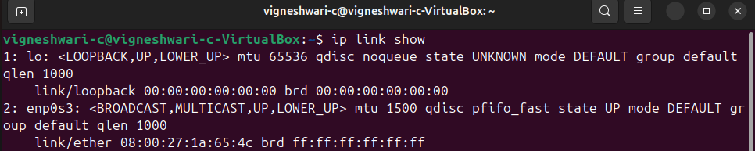

**To create a virtual bridge that acts as a switch:**

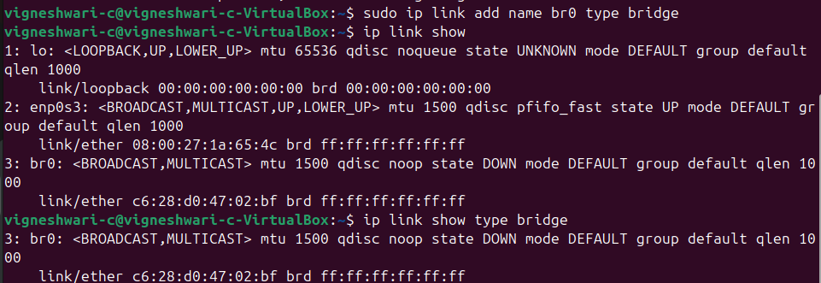

**To display the MAC address table:**

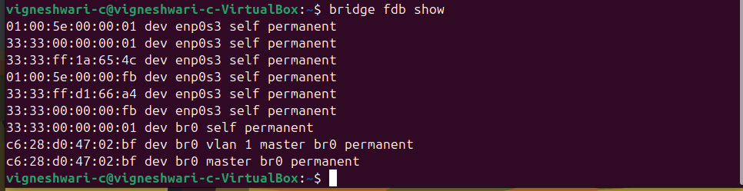

**The Linux bridge is actively forwarding traffic and participating in multicast communication. The switch is correctly maintaining a MAC forwarding table, ensuring efficient packet delivery between network interfaces**